Announcement (Front page) Ticker
Here you can set a news ticker to run across the Front page of your Moodle site.

To setup your ticker,
- On your site https://uavpilottraining.a3uav.com/courses/?redirect=0 go to home page
- Scroll down go to Administration setting section and search for ticker as shown

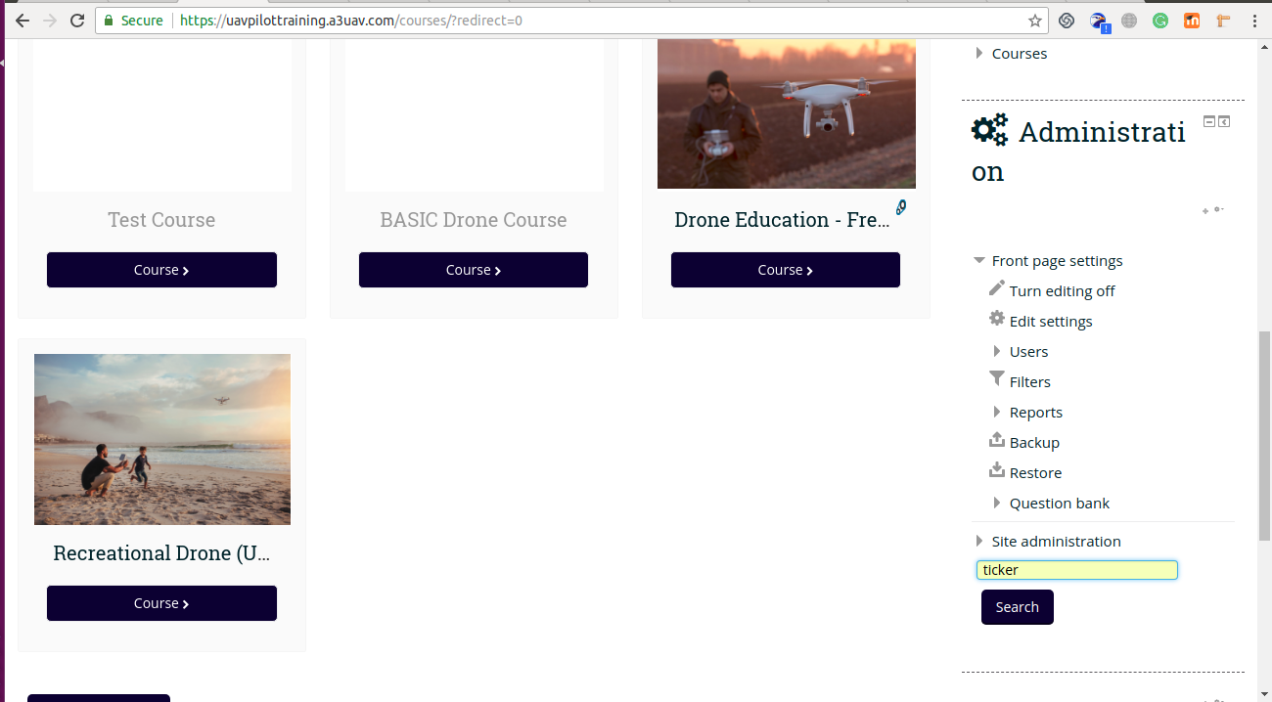

- While click search , It will lead to site administration page.
- Then scroll down and reach to News Ticker Text 1 ;
- Enter your desired ticker and hit the Save Change button. Thats it

